Life Legacy Training Manual
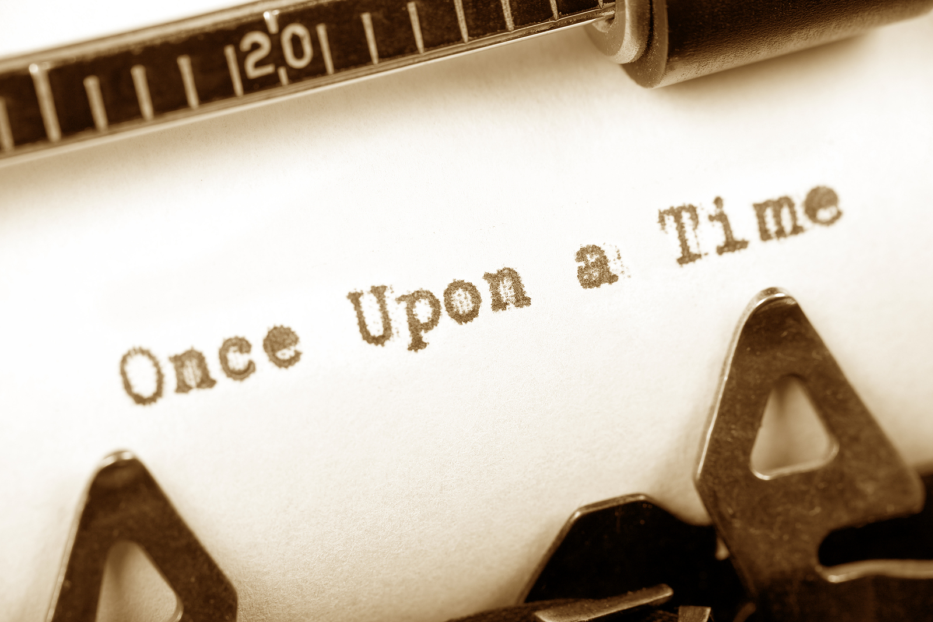

Table of Contents
Introduction……………………………………………..3
Benefits…………………………………………………….4
Appropriate patients……………………….............5
Asking the patient……………………………………..6
Confidentiality…..……………………………………..7
Life Legacy Projects…………………………………..8
All About Me Instructions…………………..9
Dear Friends and Family Instructions…11
Template……………………………………14
Memories Photo Book Instructions…….16
Finalizing the projects……………………………..19
References………………………………………………21

Introduction
Life Legacy was created to give patients a clearer understanding of the significance of their life. We want to validate their accomplishments, help to overcome their fears and failures, and be of support through the process of forgiveness.
Life Legacy has integrated a shortened version of a Structured Life Review and Reminiscence Therapy.
A Structured Life Review is typically done over several sessions and chronological from birth to present with the summarization and evaluation of the patient’s life (Haight & Haight, 2007).
Reminiscence Therapy is an informal discussion with the patient about past activities, experiences, and events and typically involves tangible props. This therapy is often done within groups (Woods et al., 2005)
Your role in this experience with the patient is to be present, listen, and help them relive their memories and feelings.
Benefits
There is a lot of research on Structured Life Reviews and Reminiscence Therapy that state the benefits in palliative care. Because this training manual does not go in-depth enough to fully train a facilitator, we cannot say the Life Legacy project will prove beneficial for every patient.
We do know that most patient’s enjoy sharing their stories and would love to have it put in writing to give their loved ones.
If all we do is help a patient to relive memories and leave something for their families to cherish forever, than we have succeeded.

Appropriate Patients
Who should participate in Life Legacy:
Those who are not actively dying
Those who are not cognitively impaired
Patient’s who are incapacitated could become too overwhelmed trying to remember past events.
Do an informal assessment to evaluate whether you believe the project would be too demanding on your patient.
You are trained to assess your patient’s needs and well being, we trust that you will be able to decide whether your patient is a good candidate. If you have questions or concerns contact the volunteer coordinator.

Asking the Patient
After determining if your patient would be a good candidate for Life Legacy, ask your patient if they would be interested in creating one or more of the Life Legacy projects.
Explain which each project consists of. The time it takes to complete each project could be drastically different with each volunteer and patient.
Let the patient know that they are in control and you are only there to assist in creating the project. Also, they can choose to stop the project at any time.

Confidentiality
All information shared for this project is confidential.
Before beginning any project the patient or person responsible will need to sign a form of consent. The consent forms will be kept with the Life Legacy Material. The consent is to allow MHHC to use the patient’s project for training purposes and agreeing to participate in the project.
Any recordings of the patient will need to be deleted after information is transcribed.
Photos will need to be kept in an envelope or if scanned on a phone, deleted once moved to a secured storage.
USB drives will need to be password protected (USB from MHHC will already be password protected). Passwords will be posted with USB.
Life Legacy Projects
There are three projects within Life Legacy:
All About Me
Dear Friends and Family
Memories Photo Book
All about me is a list of questions the patient gets to choose from to answer.
Dear Friends and Family is a letter template created by Stanford Medicine addressed to the patients’ loved ones.
Memories Photo Book is a scrapbook with the patients’ most cherished photos.

All About Me
You will need:
- Computer
- USB drive (available at MHHC if you do not want to use your own)
- Template for All About Me (available on the USB or can be emailed to you)
- Recorder (optional)
You can record patient’s answers if you have a recorder and transcribe it later or take your laptop and type as the patient answers.
The list of questions will be kept with the Life Legacy material. Patients can choose all or just a few of the questions.
Questions are listed in life stages. Patients can choose a chronological order or focus on a stage in their life.
Patients can also forgo the questions and tell about important memories or events that took place in their life.
While the patient is answering questions, ask:
- How the experience felt
- How they acted during the experience
- What were the inspirations
- What were the consequences
- How they feel about the experience now
When the patient has finished answering all chosen questions you can put the responses into the All About Me template or create a template of your own.
If you are choosing to use the template saved to the USB from MHHC be sure to save the template as a different name BEFORE making any changes.
There is a title page template for All About Me saved on the USB as well.

Dear Friends and Family
You will need:
- Computer
- USB drive (available at MHHC if you do not want to use your own)
- Template for Dear Friends and Family (available on the USB or can be emailed to you) or access website
- Recorder (optional)
You can record patient’s answers if you have a recorder and transcribe it later or take your laptop and type as the patient answers.
You DO NOT have to use this template. Patients can simply create their own letters to loved ones.
Not all information in the template will be relevant to the patient, edit it to fit the patient’s needs.
Stanford Medicine created a letter template to give all individuals an opportunity to complete the seven vital tasks of a life review:
- Acknowledge the important people in your life
- Remember treasured moments from your life
- Apologize to those you love if you’ve hurt them
- Forgive those who have hurt you
- Express the gratitude for all the care and love you have received
- Tell your friends and family how much you love them
- Take a moment to say “goodbye”
Following these instructions will be the template
or
You can either go onto the Stanford Medicine Letter website at:
https://med.stanford.edu/letter/friendsandfamily.html
- You will scroll down to the chronic illness templates
- There are several different languages to choose from.
- Once you have chosen the language you can fill in the blanks and generate the final product
or
Use the template that is saved to the USB.
Not all sections need to be answered.
If you are choosing to use the template saved to the USB from MHHC be sure to save the template as a different name BEFORE making any changes.

Dear Friends and Family Template
[Date]
Dear family and friends,
I realized that my illness may be causing you some distress. You are working hard to support me and care for me in addition to all the other roles and responsibilities that you have. Let me start by saying that I am very grateful to you for your loving care and concern. Your support is helping me cope with my illness.
[Acknowledge the people who you are proud of and their accomplishments. Ex: Taylor, I am so proud of the man you have grown to be and your successes with your career.]
I want you to know that I am proud of you.
Here are some highlights of my life and moments I have cherished.
[Enter the moments that are important to you. Ex: I always cherished the holidays when our family would come together. Remember when we would stay up all night on Christmas Eve to unwrap presents at midnight.]
[In this section write to the ones you may have hurt, ask for forgiveness for specific issues. Ex: Laura, I am so sorry I was not able to attend your graduation.]
I want to ask for your forgiveness for hurting you. I am so sorry.
[Write to those who may have hurt you. Ex: Gina, I forgive you for what happened at grandma’s funeral.]
I want you to know that I am ready to put the past behind us. Let’s work to rebuild our relationship in the time ahead.
[Write to those you want to say thank you to. What they did and why you are thankful. Ex: Alicen, thank you for driving me to church every Sunday when I could not longer drive.]
I want to say thank you for everything you have done for me.
[Acknowledge those you love. Ex: Laura, I love you for being the best sister in the world.]
I want you to know that I love you very much.
[Write specific farewell messages to those you desire. Ex: Morgan, I will always watch over you.]
I want you to know that no matter how it all turns out at the end for me, I am very grateful to you for your loving care and concern. Even if I do experience pain or distress at the end, I do not want you to feel any guilt, anger, or unhappiness over it. Nothing would make me sadder than to think that you are distressed over what happened to me.
Thank you so much for everything you have done for me. It has been a true honor, pleasure, and a privilege to have you in my life. I truly hope you find peace, love, and joy in the years to come. I love you very much.
Yours,
[Signature]

Memories Photo Book
You will need:
- Computer
- USB drive (available at MHHC if you do not want to use your own)
- Template for Memories Photo Book (available on the USB or can be emailed to you)
- Recorder (optional)
- Scanner on phone or printer
- Envelope (if you choose to take pictures to scan)
- Post-its (or something similar to distinguish what info goes to what picture)
You can record patient’s answers if you have a recording device and transcribe them later or take your laptop and type as the patient answers.
Gather pictures that the patient wants to put in the memory book. They can decide on a chronological theme from birth to present, vacations, family, or random pictures.
When patient is telling about the pictures ask:
- Who is in the picture
- When was it taken
- Where was it taken
- What were they doing
- What was the weather like
- What were their feelings during that time
When you have gathered all pictures and information scan the pictures onto the phone or with the printer and insert them into the template. You do not have to use the template if you have a better method to create the memory book.
When using the template saved to the USB from MHHC be sure to save the template as a different name BEFORE making any changes.
How To:
- Right click file
- Right click save as
- Go to save as and name the document
  - Your last name
- Go to where
  - Make sure it is saving to the USB
- Right click save
The templates are saved in PowerPoint. The slides created have an option for one or two photos and a space to enter text. There is also a title page template. The slides will look blank until you click on the slide to view it.

Finalizing the Projects
After you have finished entering information into the templates, proofread, and allow the patient to look it over. Make any changes necessary.
At this time you can also ask the patient if they would like to name their project or just use their name on the title page (All About Me and Memories Photo Book).
Once the patient has approved the final product, you can get the Life Legacy paper from MHHC and either print the project at home or bring the USB into MHHC and print at the office.
*Make sure the print setting for PowerPoint is printing slides and not outline or notes*
All About Me/Memories Photo Book
There are clear cover report folders for these two projects. After you have printed the final project use the 3 hole puncher to create holes and insert the project into the folder.
Dear Friends and Family
After you have printed the final project on the paper provided by MHHC, there are envelopes you can insert the letter into. It would look best to tri-fold the letters.

*After each project is created ERASE the information from the USB (personal or MHHC)

References
Haight, B.K., & Haight, B.S. (2007). The Handbook for Structured Life Review . Baltimore, Maryland: health professions Press, U.S.
Woods, B., Spector, A., Jones, C., Orrell, M., & Davies, S. (2005, April). Reminiscence Therapy fr Dementia . U.S. National of Medicine National Institutes of Health, (2). Retrieved from https://www.ncbi.nlm.nih.gov/pubmed/15846613

